**The discretized form of Poisson's equation** is obtained by approximating the derivatives in the equation using finite differences. To derive the discretized form, let's consider a 2D Poisson's equation:

This equation represents the discretized form of Poisson's equation on a 2D grid. Each term involves the values of *u* at neighboring grid points, and the right-hand side involves the source term *f* at the corresponding grid point. This discretized form forms the basis for iterative methods like the Jacobi, Gauss-Seidel, or other numerical approaches to solve Poisson's equation on a discrete grid.

**The Jacobi iterative method** is an iterative numerical technique used to solve linear systems of equations. It can be applied to solve Poisson's equation, a partial differential equation (PDE) that describes the steady-state distribution of a scalar field (such as temperature) in a given region. The Poisson's equation is often written as:

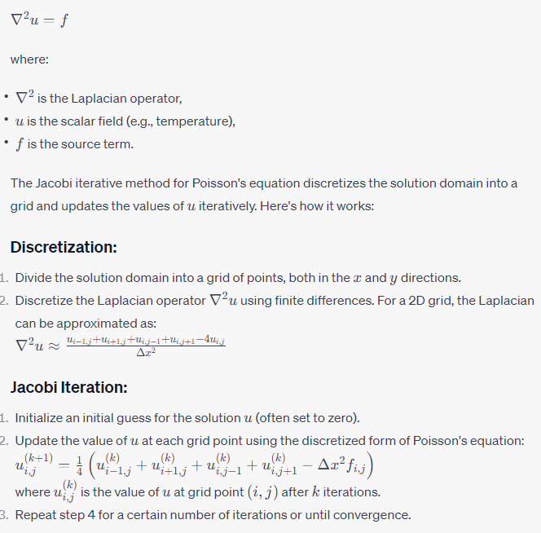

**Convergence Check:**

1. Check for convergence by comparing the difference between the current and previous iterations. If the change is below a specified tolerance, the method is considered converged.

**Implementation Notes:**

* The Jacobi method updates all grid points simultaneously. The new values are computed based on the old values from the previous iteration.
* The method can be computationally expensive as it requires storing two sets of values (current and previous iterations) and involves multiple passes through the entire grid.
* It is generally not the most efficient iterative method for solving Poisson's equation, and more advanced iterative methods like Gauss-Seidel or successive over-relaxation (SOR) are often preferred.
* The choice of the number of iterations and the convergence criteria depends on the specific problem and accuracy requirements.

The Jacobi iterative method is a basic technique for solving linear systems and can be used in various applications, including the numerical solution of Poisson's equation for steady-state problems.

Top of Form